**Name:** Adwait Purao

**UID:** 2021300101

**Batch:** 5

Install and run Kleopatra

1. Create a new key pair

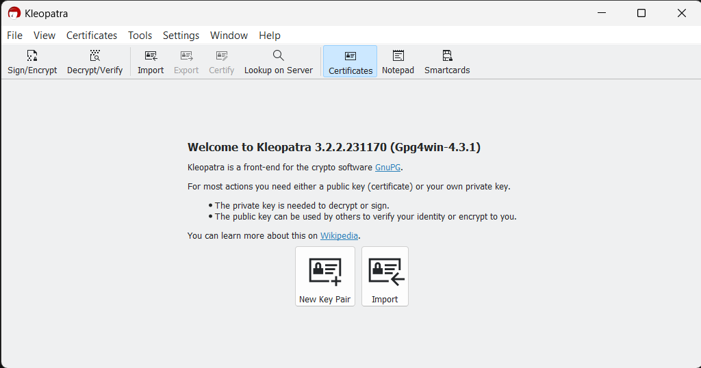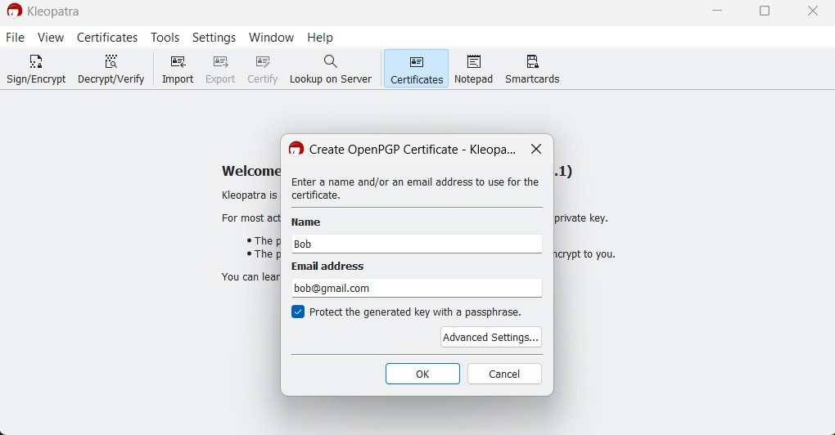

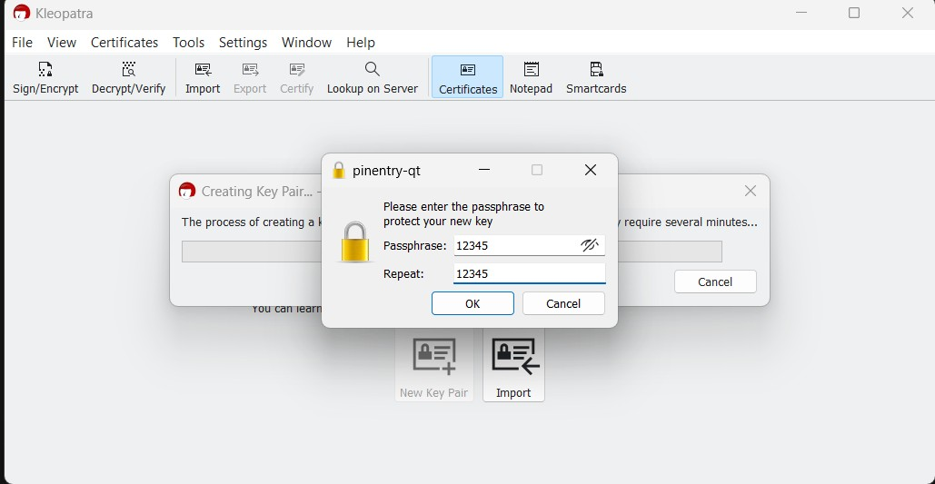

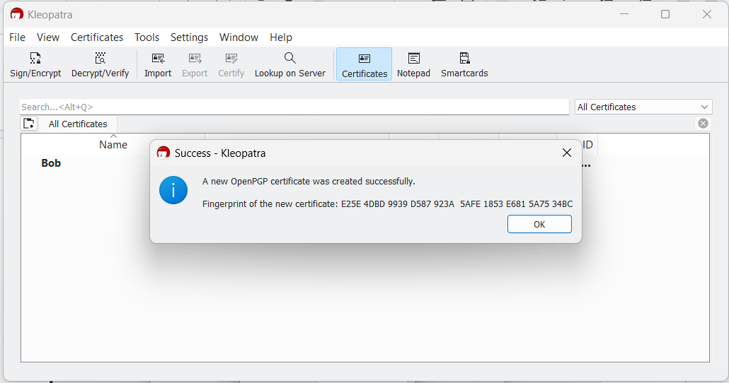

1. Export the file

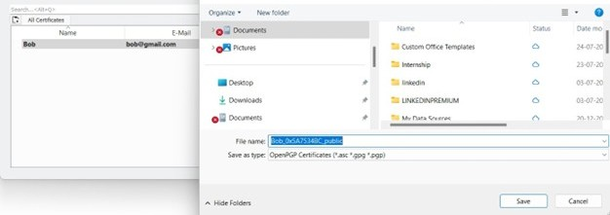

1. Backup the file

1. Take a look at Bob’s public and private key

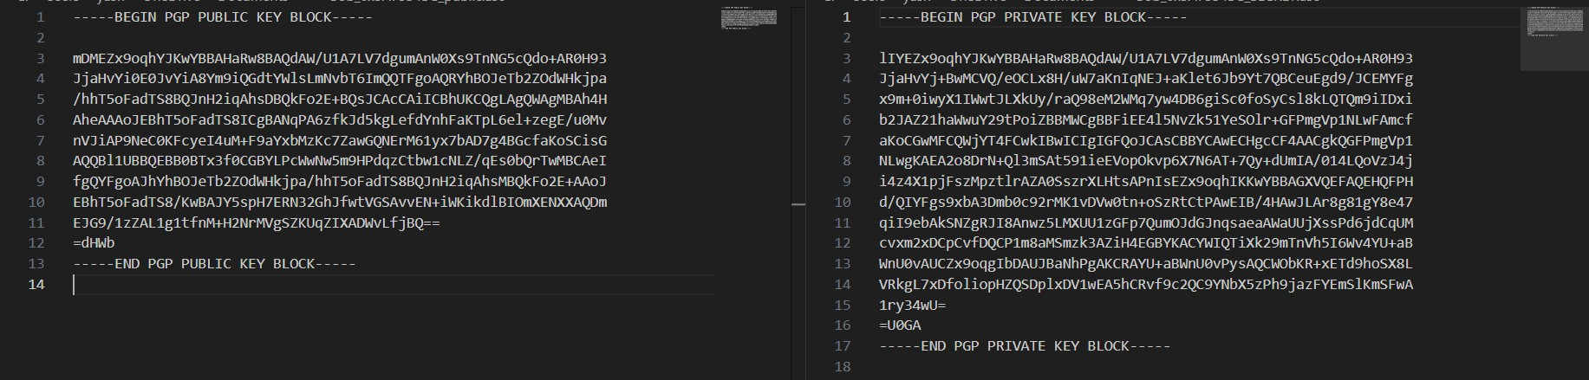

1. Similarly generate Alice’s key pair and export and backup public and private keys

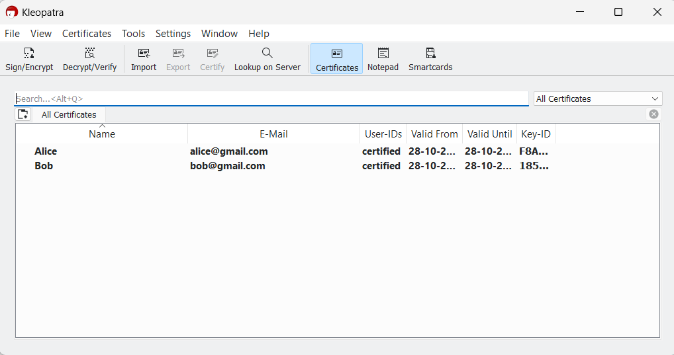

1. Take a look at Alice’s public and private key

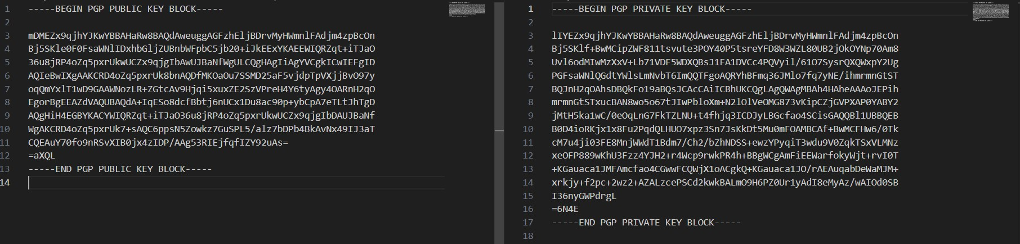

1. Now to communicate with Alice, copy public key of Alice paste into notepad and click import notepad.
2. After that add a custom message

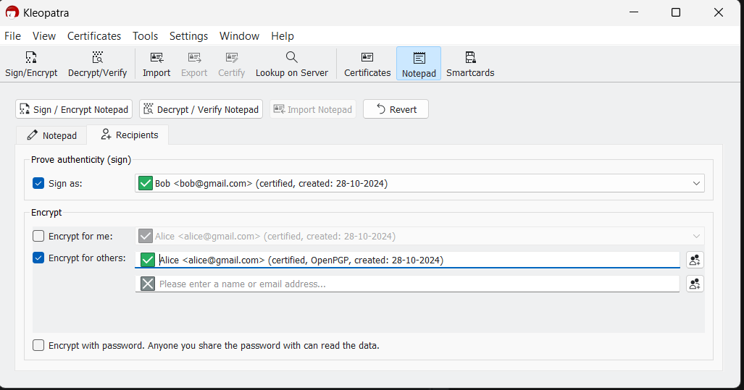

1. Sign and Encrypt Notepad

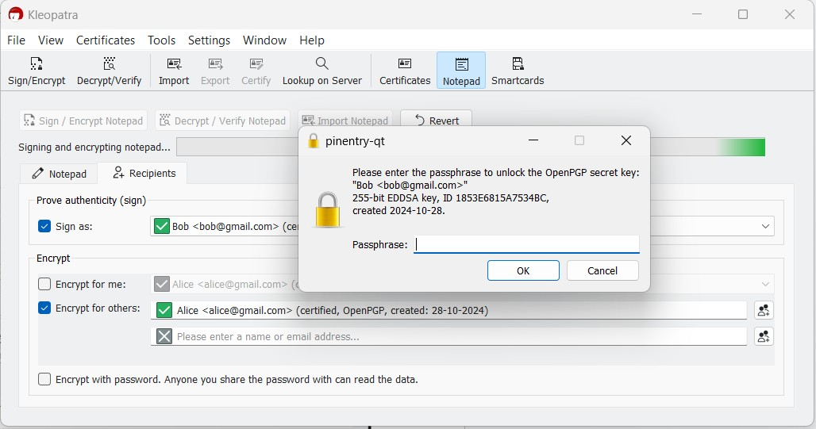

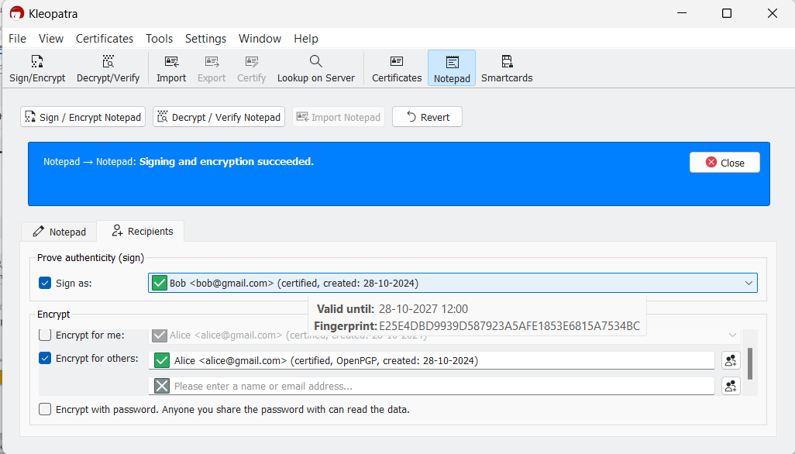

1. Copy the sent encrypted message in a text file

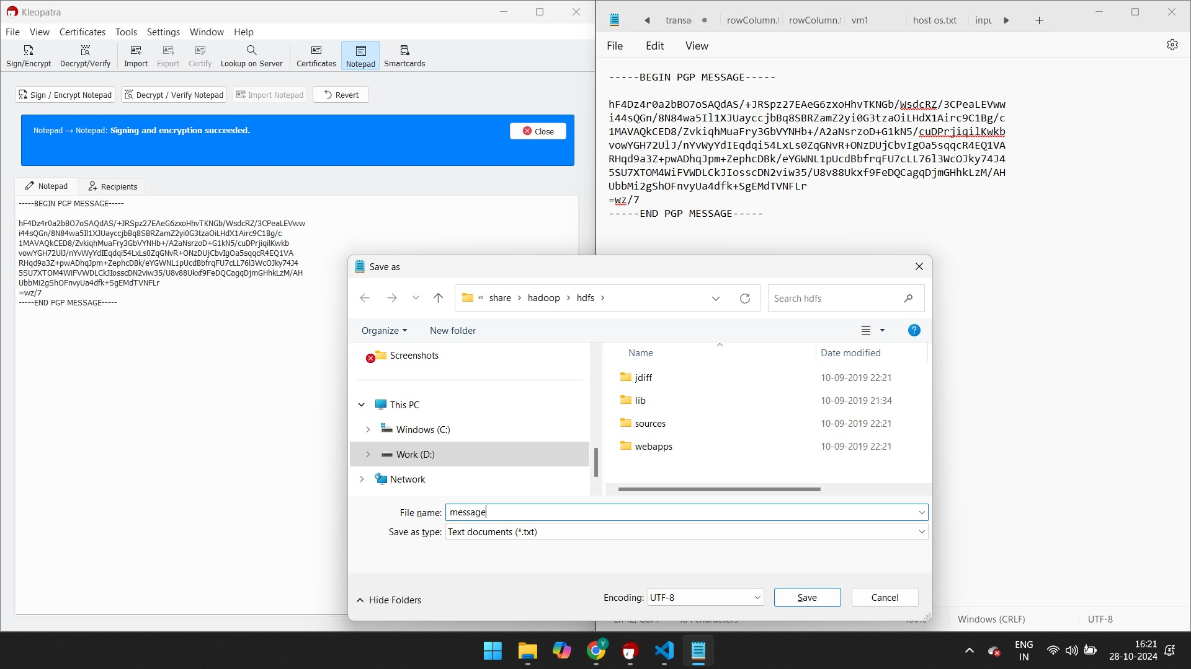

1. Now we have sent an encrypted message to Alice which can be seen only by Alice using her private key. Sign in as Alice

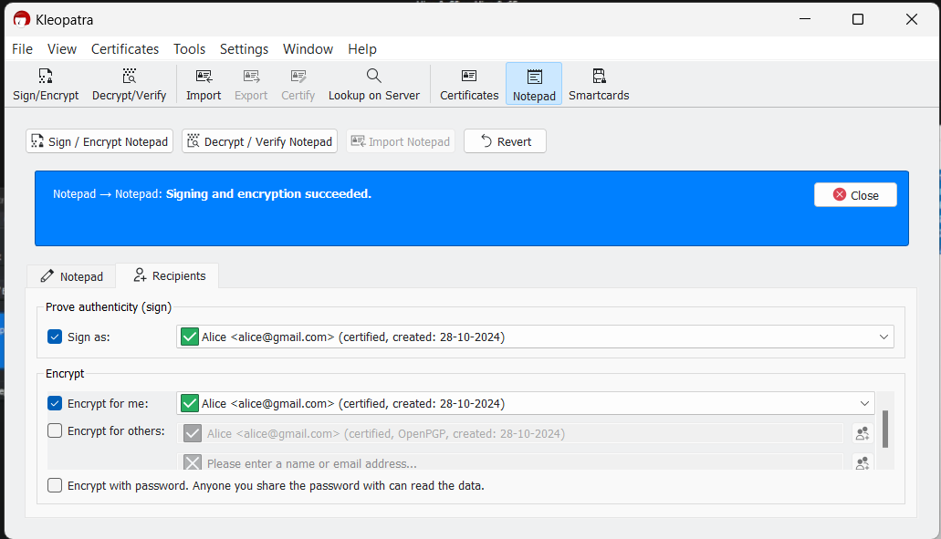

1. Decrypt the message using Alice’s Private key. Paste the copied message from the notepad and click on Decryp message button

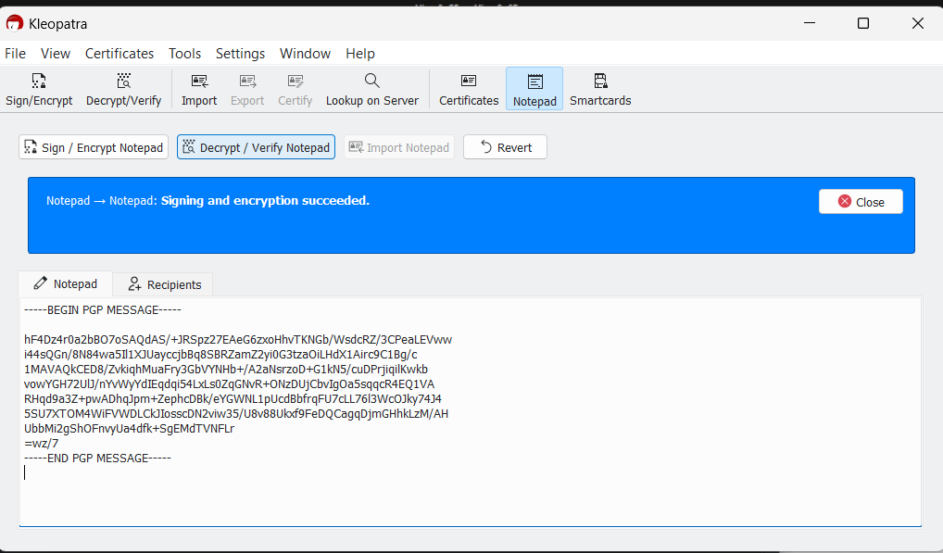

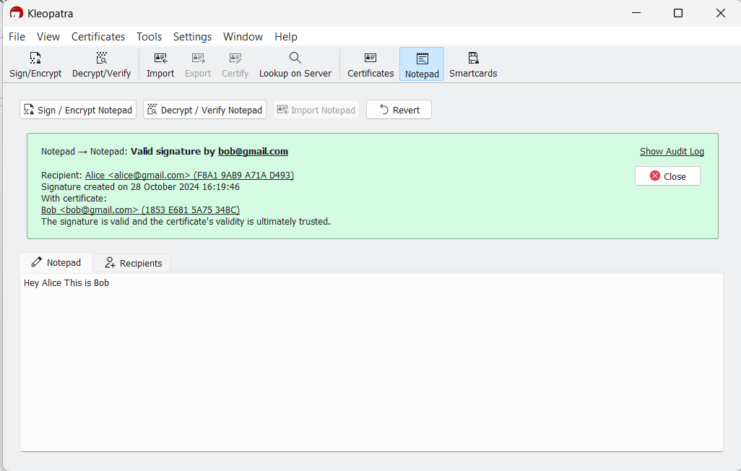

1. We are able to successfully decrypt the message certified by Bob and encrypted using Alice’s public key using Alice’s private key.

Thus Bob is able to successfully send Alice encrypted message using PGP.